SUBCOMMITTEE ON HEALTH SUBCOMMITTEE ON HUMAN RESOURCES
JIM McDERMOTT 7TH DISTRICT, WASHINGTON
CHAIRMAN CONGRESSIONAL TASK FORCE ON INTERNATIONAL HIV/AIDS
COMMITTEE ON WAYS AND MEANS
Congress of the United States
House of Representatives
Washington, DC 20515
January 26, 2003
Mr. Mansa Musa, CEO
The TraderBug Network
1111 N. 84th Street
Seattle, Washington 98103
Ms. Kibibi Monié, President, CEO Nu Black Arts West Theatre
P.O. Box 22652
Seattle, Washington 98122
Dear Mr, Musa and Ms. Monié,
I am pleased to lend my full support of the collaborative efforts of The TraderBug Network and Nu Black Arts West Theatre to strengthen and promote business and educational opportunities in Sub-Saharan Africa. The goal of The TraderBug Network and Nu Black Arts West Theatre to foster responsible business cultures while building educational cultural heritage programs among children is admirable.
As the author of HR 434, The African Growth and Opportunity Act (PL 106-200), I am a strong proponent of establishing trade relationships between American companies and their sub-Saharan Africa counterparts. Along with the business aspects, The TraderBug Network and Nu Black Arts West Theatre's integration of educational programs is an outstanding model for educating Africa's children. The development of an atmosphere that encourages such joint ventures and partnerships is an essential component for continued development in African countries. The strong relationship between The TraderBug Network and Nu Black Arts West Theatre provides the links necessary to achieve these goals.
The collaborative work of The TraderBug Network and Nu Black Arts West Theatre will advance Africa's participation in the global economy. I commend this creative endeavor and am pleased to endorse their goals.
The TraderBug Network and Nu Black Arts West Theatre have my best wishes for continued success.

Sincerely,

JIM McDERMOTT Member of Congress
1035 LONGWORTH BUILDING WASHINGTON, DC 20515-4707 (202) 225-3106
http://www.house.gov/mcdermott PRINTED ON 100% RECYCLED PAPER@
1809 7TH AVENUE, SUITE 1212 SEATTLE, WA 98101-1399 (206) 553-7170

Humanitarian Accomplishments

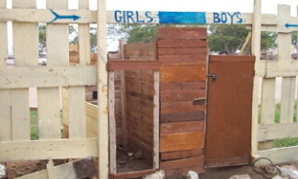

GIRLS AND BOYS RESTROOMS TEMA, GHANA

These were the only restroom facilities available for over 1,000
students at the Twedaase Primary school in Tema, Ghana West Africa.
The Traderbug Network had six toilets and plumbing built for this school.

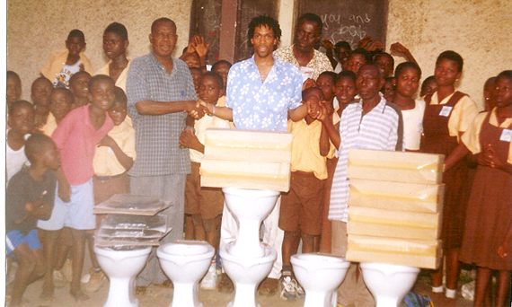

Nana Musa Standing with a Parent and the Plumbers to install new toilet stools.
What a great day for the Children at Twedaase.

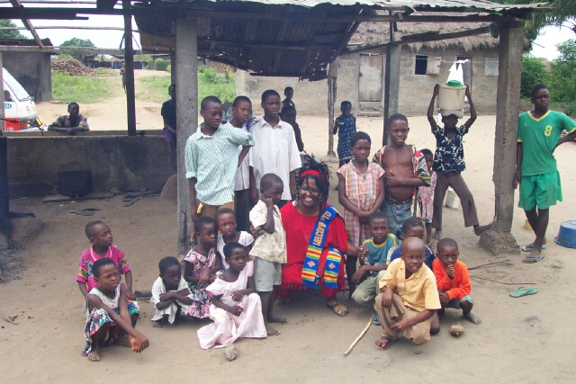

Nu Black Arts West Theatre donates school supplies to rural communities throughout Ghana, West Africa. Nana Kibibi and children from the community of a rural village located at Cape Coast posing for this picture.

Nu Black Arts West Theatre assisted in facilitating a business and cultural tour, for the D.E.C.A. students from Garfield High school in Seattle WA. This tour started April 4th and ended on April 15th 2003. The students visited Kakum National Park and
Rainforest, the Elmina Slave Castles,
Cosco Shipping (at Tema Harbor),
Bonwire Kente weaving center, the
University of Ghana and Mfantsipim School.(secondary school attended by Kofi Annan, the Secretary General of The United Nations). This is an extension of our Cultural Heritage Program.

